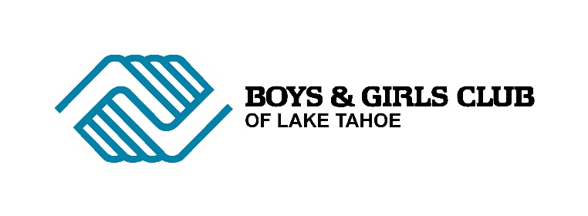

VIDEO SURVEILANCE POLICY
The Boys and Girls Club of Lake Tahoe has a camera surveillance system onside for the protection of members and staff.
The cameras are situated in all classrooms, the MPR and in the hallways.
The cameras record 24/7. Members and staff are informed of the cameras.
Membership of the Club or employment at the Club is taken as agreement to be recorded while on-site. Parents and volunteers also agree to be filmed when they enter the building.
Footage is securely stored on the cloud and is accessible only to admin. team members.
The cameras are used as a surveillance tool and also as an aid in determining the sequence of events for accidents or behavioral issues; especially when accounts differ.
Staff may request to watch footage if there is an issue they are trying to resolve and on occasions footage is used for professional development as a teaching aid.
Footage is NEVER downloaded and is never made personally available to staff or parents. Law enforcement may request copies of the footage if ever required.
In the case of accidents or incident involving a member, parents may request to review the footage, on-site, with members of the admin. team present.
Footage is kept for 1 week. Footage that is required for longer is saved separately on the cloud.

