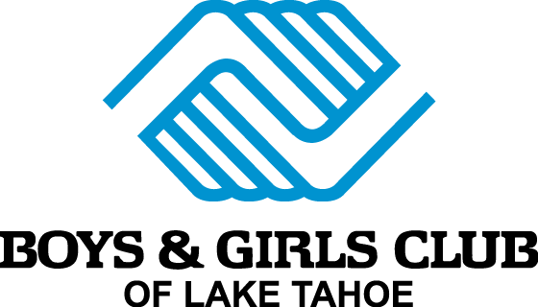 Parent/Member Agreement
The Club is making every effort possible to provide a safe and sanitized environment for our members and staff. This has required us to put in place new policies and procedures for our daily operations. Those policies and procedures have been provided to you and we ask that you read, initial and sign the following checklist to ensure that you are in full agreement with how the Club will operate this summer.
We appreciate that some of these requirements may place an extra burden on our families and any parent or member unable or unwilling to follow these guidelines will be eligible for a refund of their membership.
- I have read the policies and procedures for BGCLT Fall 2021 ……….
- I have read and signed the new COVID-19 waiver ……….
- I have discussed these policies with my child so they are aware of the expectations placed upon them for participation in Club …………
- I understand that my child may be refused participation at Club if they are running a temperature of 100F or higher upon arrival …………
- I understand that I am to provide a double layer, cloth facemask or medical paper mask for my child(ren) to wear at Club …………
- I understand that if my child(ren) refuses to adhere to social distancing and safety measures, or actively seeks to endanger another member or staff, that I will be asked to pick them up for Club and they will be unable to return until they agree to a behavior contract …………
- I understand that I cannot enter the Club unless asked to by a member of the Administrative Team and that I must wait outside or in my car to collect my child(ren) …………
- I understand that I should not send my child to the Club if they are feeling sick and that my child will not be admitted to the Club if their temperature is 100F or over …………
- I agree to help the Club in their safety measures by informing the Club immediately if my child becomes sick …………
- I understand that the Club may have to close at anytime if ordered by the County, City or LTUSD, or if there is suspected case of COVID-19 amongst members or staff …………
- I understand that I pay a membership fee for my child(ren) to attend the Club and that fee is the same regardless of how many days I attend or days that the Club is open ………….
- I understand that refunds of membership fees are only given for medical reasons or relocation outside of the Club’s service area and that documentation is required …………
- I understand that any questions, concerns or conversations that need to be directed to administrative staff will be conducted via email or over the phone unless staff request an in-person meeting …………

Please turnover the page:
If your child has any health concerns that make them at-risk should they contract COVID-19, please list them here:
………………………………………………………………………………………………………………………………………………………………………………………………………………………………………………………………………………………………………………………………………………………………………………………………………………………………………………………………
……………………………………………………………………………………………………………………………………………………

I and my child(ren) agree to abide by the guidance and policies listed in the BGCLT Fall Policies and Procedures and understand that guidance and policies may change over the course of the year due to changes in County and State regulations, and in response to continuing best practices and information being issued by the Center for Disease Control (CDC), Barton Hospital and other local agencies.

Name of member(s)………………………………………………………………………………………………………………….

…………………………………………………………………………………………………………………………………………………

…………………………………………………………………………………………………………………………………………………

Name of parent/guardian…………………………………………………………………………………………………………

Signature………………………………………………………………………………………………………………………………….

Date………………………………………………………………………………………………………………………………………….

