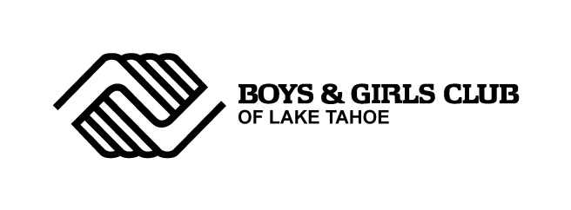
Summer 2014 Field Trips
K-1-2 Grades
- Fallen Leaf Lake 1-2 grades 7.15.14 *free
- Hospital k-1 grades 7.22.14 *free
- Taylor Creek 1-2 grades 7.31.14 *free
- Kid Zone Museum k-1 grades 8.12.14 $5
- Bowling 1-2 grades 8.21.14 $4
3-4-5 Grades
- Carson Valley Swim Center 3-4-5 grades 7.17.14 $5
- Fallen Leaf Lake 3-4-5 grades 7.2.14 *free
- Aerospace Museum of California 3-4-5 grades 7.9.14 $8
- Tahoe Science Center 3-4-5 grades 8.5.14 *free
- Discovery Museum 3-4-5 grades 8.14.14 $10
- Helping Hands Produce 3+ grades date to be determined $10
6+ Grades
- Vikingsholm 8-12 grades 6.24.14 $10
- Wild Island 8-12 grades 7.16.14 $tbd
- Grover Hot Springs 6+ grades 7.24.14 $tbd
- EZAIR 6+ grades 7.29.14 $tbd
- Round Table Buffet/Fandango Movie 8+ grades 8.7.14 $15
- Eagle Falls 6+ grades 8.13.14 *free
- Carson Valley Swim Center 6+ grades 8.19.14 $5
- Sand Harbor 6+ grades 8.22.14 *free

*field trips may be subject to change due to attendance, your child(ren) behavior may be a factor for field trips

